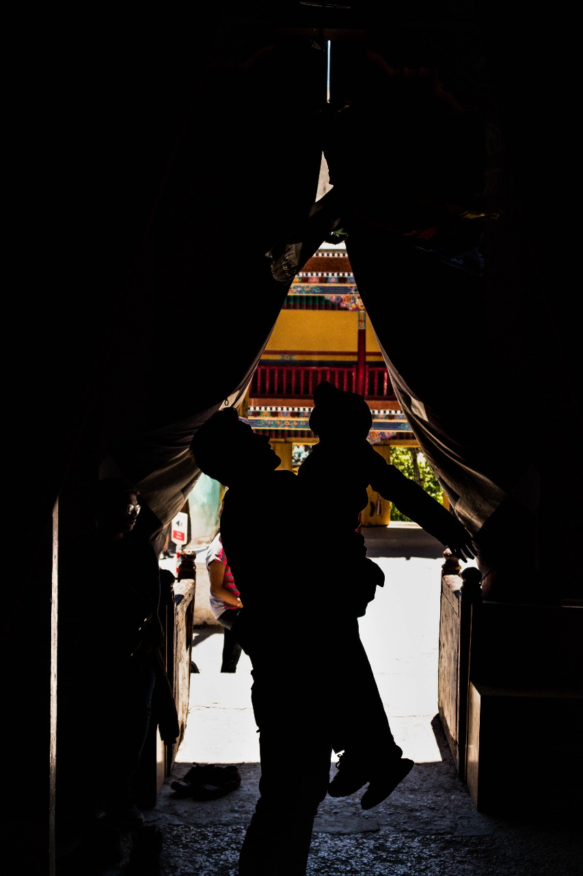
The Magic of Hemis Gompa Monastery
We landed in the early morning, greeted by the crisp mountain air and the quiet serenity of Ladakh. The hotel staff advised us to rest before beginning our tour, but how could I? I had dreamed of this place for so long, imagining its ancient monasteries, prayer flags fluttering against the clear blue sky, and the whispers of monks chanting in harmony with the wind. The excitement in me was unbearable. From my hotel window, I watched the golden rays of the rising sun bathe the mountains, itching to step outside and capture every moment.
Finally, at 10:30, we set out on our journey into this mystical world, our first stop—the famous Hemis Gompa Monastery.
“It is a Buddhist monastery located in Leh City, Ladakh,” our guide explained as we approached. “It belongs to the Drukpa lineage of Buddhism and was first established in the 11th century, later re-established in the 17th century by the Ladakhi King Sengge Namgyal. It is also famous for its two-day religious ceremony, the Hemis Festival.”
Facts. You can find them anywhere. But what no guidebook could ever tell you is what it feels like to be here.
The moment I stepped inside, a wave of peace rushed through me, as if the very air carried whispers of wisdom and serenity. The towering walls, draped in centuries of history, seemed to hum with stories of devotion and resilience. I reached out and spun a prayer wheel, watching it turn effortlessly under my fingers, sending prayers into the wind. A profound sense of calm washed over me.
My family, on the other hand, was creating their own version of serenity—by making a ruckus, excitedly pointing at everything and calling out to each other. But I couldn’t blame them. This place was a world waiting to be explored, and we were merely travelers eager to embrace its beauty.
Then, amidst the chants and the quiet rustling of prayer flags, I noticed a little boy. He was struggling to reach the monastery’s large bell, jumping with all his might but always falling just short. His tiny hands stretched towards it, determination glimmering in his eyes. For minutes, he kept trying.
Watching him, I nudged my brother. “Help him.”
Without hesitation, my brother lifted the child effortlessly, as if he were a stuffed toy. The boy’s face lit up with pure joy, his small fingers finally grasping the bell’s rope. He rang it with all his might, the chime echoing through the monastery. A victorious smile spread across his face—bright, innocent, unforgettable.
I clicked the moment. And even now, it remains my favorite memory of the trip. Those small, sparkling eyes, that uncontainable happiness—it was a reminder of the simple joys that make life magical.
Hemis Gompa had already given me a gift—one that no souvenir ever could.

